Clothıng Feature Exractıon and Classıfıcatıon

Cihat Kaya
Hüseyin Onur Taştan
Erdem Akdağlı

Izmir Democracy University Electrical Electronics Engineering Department

Abstract

This study highlights the importance of an algorithm that can classify clothing types in the fashion industry. This algorithm can help clothing companies understand the profile of potential buyers, focus sales on specific niches, and improve user experience. The study aims to evaluate these classification algorithms using important Convolutional Neural Network (CNN) models such as ResNet152, VGG16, VGG18 and clustering on data sets obtained from sources such as Kaggle and GitHub.

Keywords: Fashion, Classification Algorithms, Convolutional Neural Networks, Data Analysis, Clothing Classification

1. Introduction

This study highlights the importance of an algorithm that can identify clothing items, which can help companies in the clothing industry understand the profile of potential buyers and focus their sales on specific niches, develop campaigns according to customer taste and improve user experience. In this era of continuous growth of the online fashion market, AI approaches that can understand and label human clothing are necessary and can be used to increase sales or better understand users. This study presents Convolutional Neural Networks (CNN) models that have been shown to be effective in image classification. The specified dataset [1] contains four different CNN models that we will use (resnet152, vgg16, vgg18, yolo). Our data is a dataset that will help researchers find models that can classify products such as clothing, and provides a comparison between major classification methods to find the classification method that labels this data. This project aims to provide future research with comparisons between

better classification methods. In this report, only code testing was done with resnet152.

2. RELATED WORK

Rohrmanstorfer, S., Komarov, M., & Mödritscher,[2] Research in the field of Convolutional Neural Networks (CNNs) for fashion image classification is extensive, focusing on optimizing architecture and training strategies. This work follows a trend seen in previous studies, where adaptations of well-known CNN architectures such as AlexNet or VGG-16 are tailored to the characteristics of fashionable datasets.
Transfer learning, an important aspect of the third approach here, has been a focus in the literature. Researchers have sought to leverage pre-trained models from public datasets, particularly MNIST, for specific tasks.
In line with a broader trend, the article addresses the challenges of small dataset size using data augmentation techniques.
In summary, this study contributes to existing research by building on established practices for fashion image classification in CNNs. Exploration of model architectures, transfer learning, data augmentation, and considerations of small data sets are aligned with ongoing efforts to improve the robustness and effectiveness of deep learning models in fashion analysis.

Li, Z., Sun, Y., Wang, F., & Liu, Q.[3] This paper proposes the use of Convolutional Neural Networks (CNNs) for Clothing Classification. He notes that current algorithms have manually designed feature limitations that cause low accuracy issues. The authors create a new database by using clothing images downloaded from the internet and dividing them into 16 categories according to clothing styles.

The CNN architecture is designed to adaptively learn the feature representation of clothes. The experiment compares the proposed CNN model with traditional methods and shows that the CNN model is superior to other algorithms.

Highlighting the traditional feature limitations of previous clothing classification research and the lack of a general clothing database, the article proposes a deep learning-based approach to address these shortcomings and creates a large clothing database.

The clothing database is divided into 16 categories and contains 33,965 examples. CNN architecture consists of four convolutional layers and aims to learn hierarchical features. Experiments show that the CNN model achieves the highest accuracy of 61.22%.

In conclusion, the paper highlights the success of CNNs in recognizing clothing categories, specifically highlighting their ability to learn global knowledge and semantic features. He suggests that in the future, more work should be done to optimize the deep network architecture and expand the database.

Seo, Y., & Shin, K. S.[4], focused on the importance and use of deep learning methods for clothing classification in the fashion industry. In particular, the advantages of Convolutional Neural Networks (CNN) and other deep learning techniques in the recognition, classification and processing of fashion images are discussed. In addition, the difficulties and solutions encountered in clothing classification of these techniques are also examined in detail. The potential of hierarchical classification methods to reduce error rates and increase accuracy in garment classification was emphasized. It is emphasized that the study presented in this article has the potential to obtain more accurate and detailed results in the field of clothing classification in the fashion industry.

3. DATA SET ANALYSIS AND SELECTION

At the beginning of the study, large data sets obtained from sources such as Kaggle and GitHub were examined, an example is shown in Figure 3.1. These datasets contain high-resolution images and comprehensive category labels of clothing products. These datasets will play an important role in training models that will be used to classify clothing types. The first paragraph in each section should not be indented, but all following paragraphs within the section should be indented as these paragraphs demonstrate.
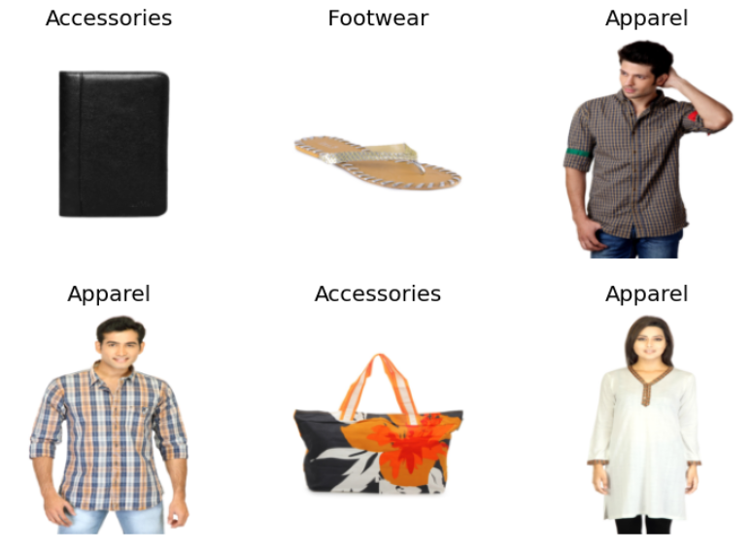
Figure 3.1 dataset

4. WORKING PROCESS

The basic stages of the study include the following steps:
  - Data Discovery and Preparation
In the first phase, data discovery and preparation were carried out. A Kaggle dataset named 'fashion-product-images-dataset' was used. This dataset contained a wide range of information about clothing products. The dataset included a CSV file and a set of product images. The CSV file contained the products' categories, colors, genders, and other attributes.
4.2 Data Analysis and Visualization
In the data analysis and visualization step, we examined the distribution of product types in the 'styles.csv' file. This helped us choose the types of clothing we would focus on in the project. In particular, we visualized the numbers and distribution of items contained in the 'articleType' column.
  - Data Preprocessing
In the data preprocessing step, we focused on the selected clothing types and processed the visual data related to these types. By selecting images of certain types of clothing, we processed these images and saved them in a new directory. This process aimed to create a data set suitable for training our deep learning model.

  - Model Selection and Design
After the pre-processing phase, important CNN model ResNet152 (it is shown in Figure 4.1). Among these models, the most suitable ones were selected to create the clothing classification model.
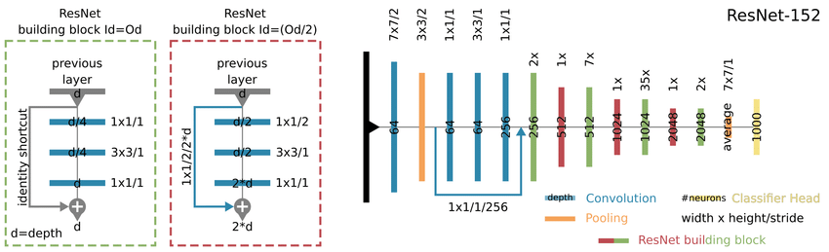
Figure 4.1 resnet152

Training Optimization: After the model design was completed, the training process of the model was optimized by selecting specific loss functions and optimization algorithms.

  - Performance Evaluation
The performance of the trained model was evaluated with appropriate metrics such as accuracy.

Overfitting occurs (shown in Figure4.2) in later epochs (starting from Epoch 2); The increasing gap between training and recovery loss demonstrates this. The model is very specific to the education system and can perform well on new, unseen data. Reductions in overfitting include using regularization techniques (e.g., dropout), reducing model complexity, or using training data.

From 2nd Epoch to 5th Epoch:
Training Loss Decreases: Training loss decreases further, indicating that the model continues to learn from the training data.

Validation Loss Increases: This is where overlearning begins. While the training loss continues to decrease, the validation loss begins to increase. This indicates that the model has started to memorize the training data, picking up noise or certain patterns in a way that does not generalize.

Accuracy Remains Constant: If accuracy on the validation set does not increase or increases very slowly, it indicates that the model's performance against new data is not improving.

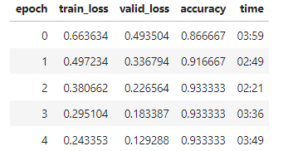
Figure 4.2 preliminary results

The performance of the trained model was evaluated with appropriate metrics such as accuracy with 93% test success achieved. We can see itsexample as Confusion Matrix in Figure 4.3. 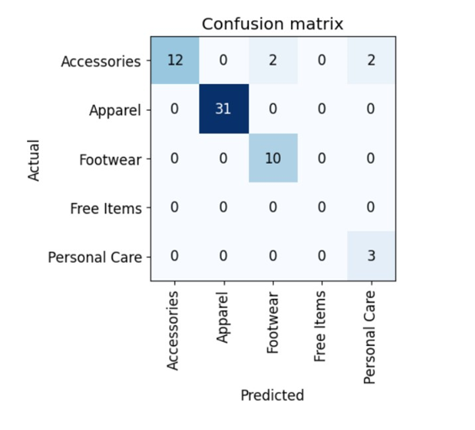
Figure 4.3 confusion matrix

4. TIMELINE

Week 1: A Comprehensive Overview of the Fashion Industry
• We focused on data analysis models used in the fashion industry.
• We evaluated popular models and analyzed their advantages and disadvantages.
• We explored how AI models used in the fashion industry may evolve in the future.

Week 2: Data Analysis for Clothing Classification
• We focused on data processing steps and analysis.
• We examined data set selection processes and image processing techniques.
• We offered insights into the importance of correct categorization in the fashion industry.

Week 3: AI Model Selection and Application
• We examined pre-trained AI models for fashion product classification.
• We found models such as CNNs, Transfer Learning (VGG16, ResNet, YOLO, Inception) suitable.
• We introduced the main purpose of using the CIFAR-10 dataset.

Week 4: Lightning.ai Application and CIFAR-10 Dataset
• We performed artificial intelligence coding using the Lightning.ai library.
• We explored the CIFAR-10 dataset, highlighting its uses and applications in machine learning research.
• We discussed the advantages of Lightning.ai and various use cases of CIFAR-10.

Week 5: Training and Model Evaluation with fast.ai
• We focused on the fast.ai library used in the fashion industry.
• We gave information about Fast.ai's democratic artificial intelligence training.
• We evaluated the training results and created a confusion matrix showing the model's correct and incorrect predictions.

5. CONCLUSION AND FUTURE STUDIES

The study aims to improve the effectiveness of garment classification algorithms in the clothing industry. The results obtained demonstrated the ability of certain models to accurately classify clothing types. Future work may focus on issues such as using more datasets, exploring new model architectures, and further optimizing the training process.

6. References

[1]https://www.kaggle.com/datasets/paramaggarwal/fashion-product-images-dataset

[2] Rohrmanstorfer, S., Komarov, M., & Mödritscher, F. (2021). Image classification for the automatic feature extraction in human worn fashion data. Mathematics, 9(6), 624.

[3] Li, Z., Sun, Y., Wang, F., & Liu, Q. (2015). Convolutional neural networks for clothes categories. In Computer Vision: CCF Chinese Conference, CCCV 2015, Xi'an, China, September 18-20, 2015, Proceedings, Part II (pp. 120-129). Springer Berlin Heidelberg.

[4] Seo, Y., & Shin, K. S. (2019). Hierarchical convolutional neural networks for fashion image classification. Expert systems with applications, 116, 328-339.

